**Steps for setting up new storefront:**

# Load the Data in Salesforce org through Data Loader

## Load CC Storefront ERP

## Load CC Categories

## Load CC Products

## Load CC Product Categories

## Load CC Price List

## Load CC Pricelist Items

## Load CC ERP Number

## Load ERP_Product_Catg_Xref data

## Load BillTo Data

## Assign JCI On All Access Permission Set

# For Categories to be reflected on Cloud craze below steps need to performed:

## Changed the Root Category Id for that specific storefront.(CC admin - Specific storefront)

## In general settings need to go in Indexing option and refresh Category Tree cache.

# Components Included in Setting up new Storefront

## Apex Classes

|  |  |
| --- | --- |
| Component Name | Comments |
| |  | | --- | | **cc_jci_ctrl_StorefrontSelection** | | **cc_jci_ctrl_CartInclude** | | **cc_jci_ctrl_MiniCartInclude** | | **cc_jci_ctrl_Guest_StorefrontSelection**  **cc_jci_ctrl_ProductDetailsInclude**  **DD_HomeController** | | |  | | --- | | **cc_jci_ctrl_StorefrontSelectionTest** | | **cc_jci_ctrl_CartIncludeTest** | | **cc_jci_ctrl_MiniCartIncludeTest** | | **cc_jci_ctrl_Guest_StorefrontSelTest** | | **cc_jci_ctrl_ProductDetailsIncludeTest** | | **DD_HomeControllerTest** | | |  | |  | |  | |  | |  | |  | | For setting up new storefront  For SaveAsQuote functionality  For Switch store,logo at homepage, etc.  For guest user storefront setup  For adding drop down list filter for colors.  For guest user browsing  For setting up new storefront  For SaveAsQuote functionality  For Switch store,logo at homepage, etc.  For guest user storefront setup  For adding drop down list filter for colors.  For guest user browsing |

## Custom Field

|  |  |  |
| --- | --- | --- |
| Component Name | Object | Comments |
| Allow Guest User Access | Storefront ERP Object | Created to display Guest user allowed storefronts |

## 

## Custom Label

|  |  |
| --- | --- |
| Component Name | Value (To be added as part of manual steps) |
| ON_LStoreEmail | 1. Navigate to Setup🡪Create🡪Custom Labels 2. Created custom label as email for footer |

## Custom Settings

|  |  |
| --- | --- |
| Component Name | Value (To be added as part of manual steps) |
|  |  |

## Visual Force Pages

|  |  |  |
| --- | --- | --- |
| Component Name | | Comments |
| cc_jci_Guest_StorefrontSelection  cc_jci_StorefrontSelection | For guest user storefront setup  For setting up new storefront | |

## Visual Force Components

|  |  |  |
| --- | --- | --- |
| Component Name | | Comments |
| DD_headerPublic  cc_jci_MyAccountContactInfoInclude  cc_jci_ProductListInclude  cc_jci_ProductDetailsInclude  cc_jci_HeaderInclude  cc_jci_MenuInclude  cc_jci_CCHeaderInclude  cc_jci_FooterInclude  cc_jci_CartInclude   |  | | --- | |  | |  | |  | |  | |  | |  | | For editing browse button on top left side of page.  For showing accurate message on top of My Profile,Manage address book page  To appear Reliable logo for product icon and also for adding drop down list filter for colors.    For Switch store,logo at homepage, etc.  For Switch store,logo at homepage, etc.  For Switch store,logo at homepage, etc.  For changing footer email id  For SaveAsQuote functionality | |

## Static Resources

|  |  |
| --- | --- |
| Component Name | Comments |
| cc_jci_OrdNavLouvers_Theme  cc_jci_OrdNavControls_Theme | Logo for Reliable Architectural Products Store  Logo for Controls Store |

**Manual Steps for Creation of new Storefront(RK Store):**

1. First to show storefronts on selection page we need to add our new store in **cc_jci_StorefrontSelection** vf page and also in **cc_jci_ctrl_StorefrontSelection** class.

And after that we need to run below queries to match the records and check storefronts count for a particular user:

select ERP_Name__c from Bill_To__c where Acct__c=:effectiveAccountId

select Storefront_Name__c, ERP_Name__c  from CC_Storefront_ERP__c

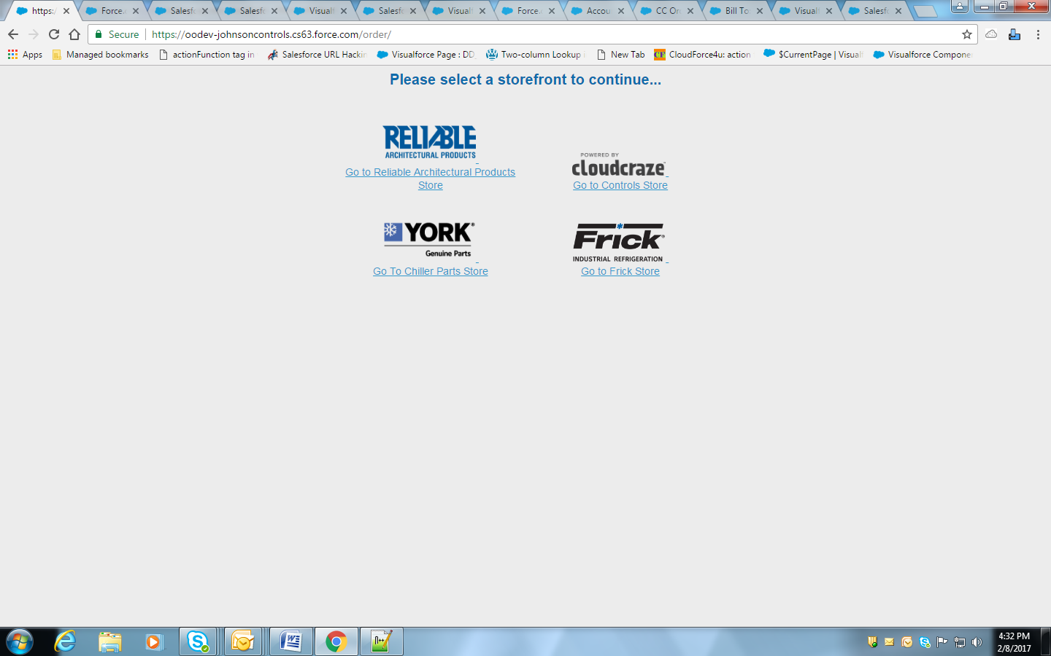

Need to add images for new storefront in Static resources and name it properly in **cc_jci_ctrl_StorefrontSelection** class (e.g **cc_jci_OrdNavLouvers_Theme**)

1. Guest User Browsing:

We need to change constructor of **DD_HomeController** classand after that need to create new **cc_jci_Guest_StorefrontSelection** vf page and **cc_jci_ctrl_Guest_StorefrontSelection** class for guest users.

1. For Homepage:

We have modified the classes and visualforce components corresponding to red highlighted box contents.

cc_jci_HeaderInclude(VF Component)

cc_jci_MenuInclude(VF Component)

cc_jci_CCHeaderInclude(VF Component)

cc_jci_ctrl_MiniCartInclude(Apex class)

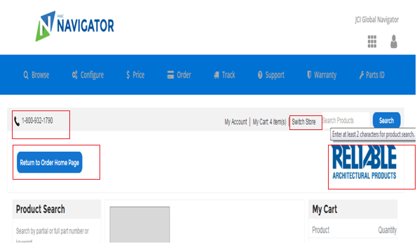

1. For Categories to be reflected on Cloud craze below steps need to performed:

## Changed the Root Category Id for that specific storefront.(CC admin - Specific storefront)

## In general settings need to go in Indexing option and refresh Category Tree cache.

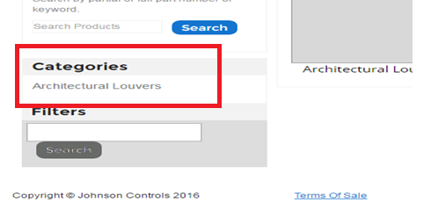

1. For changing Footer email id for new storefront need to modify **cc_jci_FooterInclude** vf component.

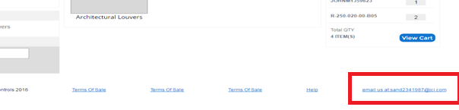

Created custom label for storing footer email id: **ON_LStoreEmail**